Trellech SAFEGUARDING POLICY

October 2019 - amended

Christofi, Karen

Trellech SAFEGUARDING POLICY

Safeguarding Policy Trellech Primary School

Working with Monmouthshire CC
The policy provides a framework which ensures that policies and practices within the Council are consistent and in line with Monmouthshire’s stated values, and which must underpin all work with children, young people, and adults at risk.
The intention of this policy is to support quality service delivery, promote good practice, and ensure services are delivered in a way that children, young people and adults at risk

2. PRINCIPLES OF THE POLICY

This policy is underpinned by the Council’s vision to build sustainable and resilient communities and the 4 wellbeing objectives:
- To develop opportunities for communities and businesses to ensure a well-connected and thriving county;
- Maximise the benefits of the natural and built environment for the well-being of current and future generations;
- Maximise the potential in our communities to improve wellbeing for people throughout the course of their life;
- Provide children and young people with the best possible start in life to help them achieve better outcomes.
There is an expectation that all of the workforce, Councillors and partners share an objective to help keep children, young people and adults at risk safe by contributing to:
- Creating and maintaining a safe environment;
- Identifying where there are concerns and taking action to address them in partnership with other agencies;
- Prevent unsuitable people from working with children, young people and adults at risk;
- Ensure the whole workforce understands safeguarding and their accountabilities and responsibilities;
Promote safe practice and challenge poor and unsafe practice

Trellech SAFEGUARDING POLICY

Introduction

  - Trellech Primary School fully recognises the contribution it makes to safeguarding adults and children at risk.

There are three main elements to our policy:-

- Prevention;
- Procedures for identifying and reporting cases, or suspected cases of adults and children at risk.
- Support to those who may have experienced abuse or harm.

  - This policy applies to all staff and volunteers working in Trellech Primary School. It is recognised that staff who come into contact with adults and children can often be the first point of disclosure of abuse or harm. This first point of contact is an important part of the protection process and it is essential that all staff are aware of and implement the procedures as noted in this policy.

Prevention

2.1 We recognise that high self-esteem, confidence, supportive friends and good lines of communication with a trusted adult help to safeguard adults and children at Trellech Primary School.

We will therefore:-

- Establish and maintain an ethos where children and adults feel secure, are encouraged to talk and share their concerns and will be listened to;
- Ensure that those attending this setting/using this service know that all staff and volunteers in this setting can be approached if they are worried or concerned about matters that concern them or their family members or friends.
- Include in the ethos of the setting that people have the right to be safe from abuse and to know that they can turn to staff for help;

Procedures

3.1 At Trellech Primary School we will follow the All Wales Child Protection Procedures 2008, and relevant adult protection procedures and other guidance and protocols that have been endorsed and agreed by the South East Wales Safeguarding Children Board (SEWSCB) and the Gwent Wide Adult Safeguarding Board (GWASB).

  - Trellech Primary School will:-

- Ensure it has a named designated senior member of staff (DSL) who has undertaken the appropriate training in line with agreed national and local requirements. This setting/service will also nominate a named deputy who will be the central contact at times when the designated person is absent. In the unlikelihood that both are absent or unavailable the most senior person will act as a contact point for other staff.
- Recognise the role of designated person and arrange support and training. The setting/service will look to the SEWSCB, GWASB and to the local authority for guidance and support in all child protection matters and concerns for adults at risk.
- Ensure that all members of staff, including permanent, part time and adult volunteers, (and school governors/management boards) knows:-

- The name and contact details of both the designated and deputy person responsible for child protection and concerns for adults at risk;
- That it is the named designated person and/or their deputy who have the responsibility for making referrals for children/adults at risk within timescales, by completing the agreed multi-agency form.
- That the designated person and deputy will seek advice from the Designated Officer and or Social Services Duty Team if necessary when a referral is being considered; if in doubt a referral must be sent.
- Ensure that all members of staff are aware of the need to be alert to signs of abuse and know how to respond to an adult or child who may disclose abuse. That all members of staff will be offered and expected to attend appropriate training and updates as arranged by the setting/service.
- Ensure that adults, children and carer have a clear understanding of the responsibility placed on the setting/service and its staff for safeguarding adults and children by setting out their obligations in relevant service/setting information.
- Provide training for all staff so that they:-

    - Understand their personal responsibility;
    - Are cognisant of agreed local procedures
    - Understand the need to be vigilant in identifying suspected cases of abuse;
    - Know how to support an adult or child who discloses abuse, particularly the do’s and don’ts.
- Work to develop effective links with relevant agencies and co-operate as required with their enquiries regarding children and adults at risk including attendance at child protection/case conferences and subsequent meetings and support these with the submission of written reports.
- Keep written records of concerns about adults and children at risk (noting date, event and action taken), even where there is no need to refer the matter to agencies responsible for formal investigation.
- Ensure that all records and files are kept secure and in locked locations. The designated person is responsible for the security, compilation and storage of all records and should be able to access and produce them in times of need. It is the responsibility of the designated person to ensure that any transfer of records is conducted sensitively and securely.

- Ensure that all recruitment and selection procedures follow all national and local guidance. The setting/service will seek advice and guidance from the appropriate Human Resources on recruitment and selection.
- Seek to designate a governor for child protection who will champion and oversee the school’s child protection policy and practice. This governor will feed back to the Governing body on child protection matters as and when required but will be required to write an annual report to the governing body on the school’s child protection activities.

Supporting children and adults at risk of abuse

4.1 At Trellech Primary School we recognise that those who are at risk, suffer abuse or witness violence are often affected in adverse ways, some may be deeply troubled by these events.

4.2 At Trellech Primary School we will endeavour to be patient and supportive to those at risk of harm or abuse.

Prevent Duties

In March 2015, the Counter Terrorism and Security Act received Royal Assent. The Act includes how we need to work together to prevent people from being drawn into terrorism.
Where we become aware of information involving identification of potential instances of extremism and radicalisation we will refer to Adult/Children’s Services in the same way as for all safeguarding concerns.

Information for all staff/volunteers

5.1 What to do if a child or adult tells you they have been abused or harmed

A person may confide in any member of staff/volunteer. Staff to whom an allegation is made should remember:-

- Yours is a listening role, do not interrupt the person when they are freely recalling events. Limit any questions to clarifying your understanding of what the person is saying. Any questions should be framed in an open manner so not to lead the person;
- You must report orally to the Designated Person Safeguarding (DSL) or their Deputy in their absence immediately to inform them of what has been disclosed. In the unlikelihood of both being absent seek out the most senior person in the setting/service;
- Make a note of the discussion, as soon as is reasonably practical (but within 24 hours) to pass on to the Designated Safeguarding Lead. The note which should be clear in its use of terminology should record the time, date, place, and people who were present and should record the person’s answers/responses in exactly the way they were said as far as possible. This note will in most cases be the only written record of what has been disclosed and as it records the initial disclosure from the person it is an important one in the child protection process.

Remember, your note of the discussion may be used in any subsequent formal investigation and or court proceedings. It is advised that you retain a copy in a safe place;
- Do not give undertakings of absolute confidentiality. (see note following this section for more details) You will need to express this in age/understanding related ways to the person as soon as appropriately possible during the disclosure. This may result in the person ‘clamming up’ and not completing the disclosure, but you will still be required to share the fact that they have a shared a concern with you to the designated person. Often what is initially shared can the tip of an iceberg;
- Your responsibility in terms of referring concerns ends at this point, but you may have a future role in terms of supporting the person, contributing to an assessment or supporting safeguarding plans. You can ask the designated person for an update but they are restricted by procedures and confidentiality and may be limited in their response. The level of feedback will be on a need to know basis, but whatever is shared is strictly confidential and not for general discussion with others.

If an allegation of abuse is made against a member of staff/volunteer this must be reported to the Designated Person for Safeguarding (DSL).
Where the allegation is against a member of staff you should refer to Children’s/Adult Services in the same way as for all allegations of abuse.

Confidentiality

6.1 A person may only feel confident to confide in a member of staff/volunteer if they feel that the information will not be divulged to anyone else. However we all have a responsibility to share relevant information about the protection of children and adults with the designated statutory agencies when a person is experiencing harm or abuse.

It is important that each member of staff/volunteer deals with this sensitively and explains to the person that they must inform the appropriate people who can help them, but they will only tell those who need to know in order to be able to help. Staff should reassure the person and tell them that their situation will not be common knowledge within the setting/service (i.e. not discussed with other staff) Staff/volunteers need to be aware that it may well have taken significant courage on the part of the person to disclose the information and they may also be experiencing conflicting emotions, involving feelings of guilt, embarrassment, disloyalty (if the abuser is someone close) and hurt.

Training

The setting/service will be cognisant of national and local training requirements and guidance, which will include SEWSCB and GWASB guidance, advice and training opportunities.

7.1 The service/setting will ensure that the Designated Safeguarding Lead (DSL) will have received initial training when starting their role and continued professional updates as required. Specific updates as suggested by national and local

requirements will be central to the DSL’s development. The designated deputy will be initially supported by the designated person and consideration for joint opportunities for training with the designated person will be given.

7.2 All staff/ volunteers will be regularly updated during the year as appropriate from the designated lead, but will receive specific awareness raising training within a 2 year period.

The Designated Safeguarding Lead at this setting is:-
Karen Christofi, Headteacher

The Deputy Designated Safeguarding Lead at this setting is:-
Kate Peacock, Deputy Headteacher

Monmouthshire Children’s Services can be contacted as follows:-

Phone: 01291 635669

Out of hours telephone number: 0800 328 4432

Monmouthshire Adult Services can be contacted as follows:-
In an emergency, please call 999 to report a vulnerable adult at risk

- Monday – Friday 9am to 5pm we operate a duty service in each locality.
- If you are reporting an adult at risk who lives in South Monmouthshire, you can speak to someone on telephone number 01291 635666.
- If you are reporting an adult at risk who lives in Abergavenny area, you can speak to someone on telephone number 01873 735885.
- If you are reporting an adult at risk who lives in Monmouth area, you can speak to someone on telephone number 01600 775100.
- Outside of office hours you can contact the Adult Services Emergency Duty Team on 0800 3284432.

This policy was updated on Monday 30 September 2019 by Karen Christofi

Staff/volunteers were made aware of this policy and or updates on Wednesdua 2nd October 2019.

Appendix 1
Safeguarding in Education
Roles and Responsibilities in Schools
- The role of the Governing Body in Maintained Schools in Monmouthshire
Governing bodies of maintained schools, governing bodies (Corporations) of FE institutions, and proprietors of independent schools in Monmouthshire should ensure that their respective organisations:
- Have effective child protection policies and procedures in place that are:
- In accordance with local authority guidance and locally agreed interagency procedures;
- Inclusive of services that extend beyond the school day (e.g. boarding accommodation, community activities on school premises, etc.);
- Reviewed at least annually;
- Made available to parents or carers on request;
- Provided in a format appropriate to the understanding of children, particularly where schools cater for children with additional needs.

- Operate safe recruitment procedures that take account of the need to safeguard children and young people, including arrangements to ensure that all appropriate checks are carried out on new staff and volunteers who will work with children, including relevant DBS checks.

- Ensure that the head teacher/principal and all other permanent staff and volunteers who work with children undertake appropriate training to equip them with the knowledge and skills that are necessary to carry out their responsibilities for child protection effectively, which is kept up-to date by refresher training.

- Give clear guidance to temporary staff and volunteers providing cover during short-term absences and who will be working with children and young people on the organisation’s arrangements for child protection and their responsibilities.

- Ensure that the governing body/proprietor remedies without delay any deficiencies or weaknesses in regard to child protection arrangements that are brought to its attention.

- Ensure that the designated senior person (DSP) for child protection, the designated governor, and the chair of governors undertakes training in inter-agency working that is provided by, or to standards agreed by, the Safeguarding Children Board and refresher training to keep their knowledge and skills up to date, in addition to basic child protection training.
(See ‘Keeping Learners Safe - The role of local authorities, governing bodies and proprietors of independent schools under the Education Act 2002’)
- Additional responsibilities of community Focussed Schools, Pre and Post School Learning and Out of Hours Learning Providers in Monmouthshire.
The governing body of a school controls the use of the school premises both during and outside school hours, except where a trust deed allows a person other than the governing body to control the use of the premises, or a transfer of control agreement has been made. Governing bodies can enter into transfer of control agreements in order to share control of the school premises with another body, or transfer control to it. The other body, known as the “controlling body”, will control the occupation and use of the premises during the times specified in the agreement.
Transferring control of the premises to local community groups, sports associations, and service providers can enable school facilities to be used without needing ongoing management or administrative time from school staff.
Where the governing body provides services or activities directly under the supervision or management of school staff, the school’s arrangements for child protection will apply. Where services or activities are provided separately by another body, the governing body must confirm that the body concerned has appropriate policies and procedures in place in regard to safeguarding children and child protection and there are arrangements to liaise with the school on these matters where appropriate.
(c) Responsibilities of Head teachers
Head teachers and principals of all schools should ensure that all staff (including supply teachers and volunteers):
- Are aware of child protection policies and procedures adopted by the governing body or proprietor are fully implemented and followed by all staff;
- Can access sufficient resources and time to enable them to discharge their responsibilities, including taking part in strategy discussions and other inter-agency meetings, and contributing to the assessment of children;
- Understand the procedures for safeguarding children, and feel able to, raise concerns about poor or unsafe practice, and that such concerns are addressed sensitively and effectively in a timely manner in accordance with agreed Welsh Government Procedures for Whistleblowing in Schools and Model Policy;
- As part of their induction, are given a written statement about the school’s policy and procedures, and the name and contact details of the DSP for child protection when they start work in a new establishment.

(d) Role of the Designated Person in Schools
The designated senior person for safeguarding in a school fulfils an essential role in developing and implementing policies that help to safeguard adults and children from all forms of abuse and create a safe environment. Refer to Keeping Learners Safe
Each setting should identify a Designated Senior Person (DSP) with lead responsibility for managing adult and child protection and safeguarding issues and cases.

The DSP should know how to recognise and identify the signs of abuse and neglect and know when it is appropriate to make a referral to the relevant investigating agencies.
The role involves providing advice and support to other staff, making referrals to, and liaising and working with, other agencies as necessary. The DSP role is not to investigate allegations, but they must keep the head teacher informed of all adult/child protection issues in the establishment.
The DSP must be a senior officer at the setting or part of the senior leadership team with the status and authority within the organisation to carry out the duties of the post, including committing resources to child protection matters, and where appropriate directing other staff. Dealing with individual cases may be a responsibility of other staff members, but it is important that a senior member of staff takes responsibility for this area of work.
In many schools and settings a single designated person will be sufficient, but a deputy should be available to act in their absence. In establishments which are organised on different sites or with separate management structures, there should be a designated person for each part or site. In large organisations, or those with a large number of adult/child protection concerns, it may be necessary to have a number of deputies to deal with the responsibilities.
The establishment must also make arrangements to cover the role of the DSP when that person is unavailable. In many cases, there will be a deputy DSP in place and larger schools may have a team of staff working together.
The DSP does not have to be an expert in the area of adult/child protection but will take responsibility for the establishment’s adult/child protection practice, policy, procedures and professional development working with other agencies as necessary. The head teacher should ensure that the DSP:

Appendix 2
Referral Process - Children
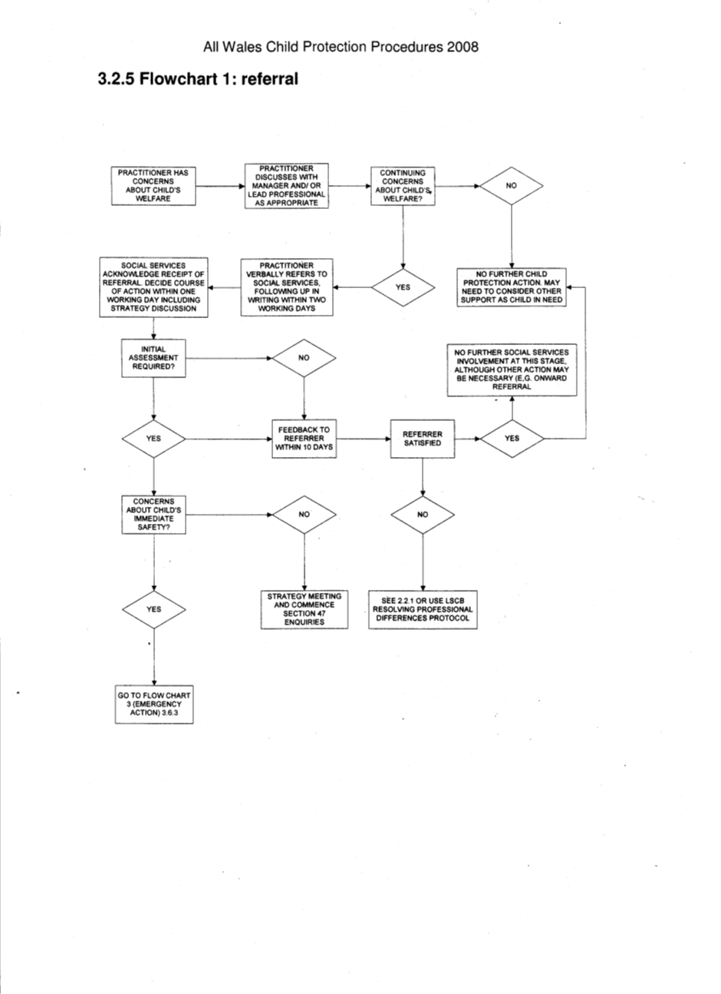

Appendix 3
Definitions of Abuse
Physical abuse
Physical abuse may involve hitting, shaking, throwing, poisoning, burning or scalding, drowning, suffocating, or otherwise causing physical harm to a child.
Physical harm may also be caused when a parent or caregiver fabricates or induces illness in a child whom they are looking after.
Emotional abuse
Emotional abuse is the persistent emotional ill treatment of a child such as to cause severe and persistent adverse effects on the child’s emotional development. It may involve conveying to a child that they are worthless or unloved, inadequate or valued only in so far as they meet the needs of another person. It may feature age or developmentally inappropriate expectations being imposed on children. It may involve causing children frequently to feel frightened or in danger, for example by witnessing domestic abuse within the home or being bullied, or, the exploitation or corruption of children. Some level of emotional abuse is involved in all types of ill treatment of a child, though it may occur alone.
Sexual abuse
Sexual abuse involves forcing or enticing a child or young person to take part in sexual activities, whether or not the child is aware of what is happening. The activities may involve physical contact, including penetrative or non-penetrative acts. They may include non-contact activities, such as involving children in looking at, or in the production of, pornographic material or watching sexual activities, or encouraging children to behave in sexually inappropriate ways.
Neglect
Neglect is the persistent failure to meet a child’s basic physical and/or psychological needs, likely to result in the serious impairment of the child’s health or development. It may involve a parent or caregiver failing to provide adequate food, shelter and clothing, failing to protect a child from physical harm or danger, or the failure to ensure access to appropriate medical care or treatment. It may also include neglect of, or unresponsiveness to, a child’s basic emotional needs.
In addition, neglect may occur during pregnancy as a result of maternal substance misuse.
Financial Abuse
Financial or material abuse is any theft or misuse of a person’s money, property or resources by a person in a position of, or expectation of, trust to a vulnerable person. Common forms of financial abuse are misuse by others of a vulnerable adult’s state benefits or undue pressure to change wills. Financial/material abuse may also be perpetrated by one vulnerable adult upon another.

Appendix 4
Relevant Legislation and Contact Details
- Social Services and Wellbeing Act (Wales) 2014
- Children Act 1989, 2004
- Carers Act 2004
- Human Rights Act 1998
- Equalities Act 2010
- Framework for Assessing Children and their Need (2001)
- Stronger Partnership’s for Better Outcomes (2006)
- Wales Interim Policy & Procedures for the Protection of Vulnerable Adults from Abuse (2010)
- Mental Capacity Act 2005
- All Wales Child Protection Procedures (2008)
- NSF for Children, Young People and Maternity Services
- Direct Payment’s Guidance
- Violence against Women, Domestic Abuse and Sexual Violence Act 2015
- Data Protection Act
- United Nations Convention on the Rights of the Child 1989
- VAWDASV Regional Service - www.gwasb.org.uk/fileadmin/documents/Handout_7_-_Gwent_VAWDASV_services_directory_3__amended_16.12.16_HG.pdf.
- PREVENT www.gov.uk/government/uploads/system/uploads/attachment_data/file/445977/3799_Revised_Prevent_Duty_Guidance__England_Wales_V2-Interactive.pdf.
Keeping Learners Safe www.childreninwales.org.uk%2Fpolicy-document%2Fkeeping-learners-safe-role-local-authorities-governing-bodies-proprietors-independent-schools-education-act-2002-

Relevant Contacts

Social Services Duty – Children Services | 01291 635669 during office hours  0800 328 4432 out of office hours
Social Services Duty – Adult Services | Monmouth/Usk/Raglan – 01600 773041  Abergavenny – 01873 735885  Chepstow/Caldicot – 01291 635666
PREVENT | Shereen.Williams@newport.gov.uk
South East Wales Safeguarding Board | www.sewsc.org.uk
Gwent Wide Adult Safeguarding Board | www.gwasb.org.uk
Buddy Support and Advice | www.buddyapp.monmouthshire.gov.uk.
Modern Slavery /Trafficking – Training and Victim Support | BAWSO www.bawso.org.uk.

